

**GROUP ASSIGNMENT**

**TECHNOLOGY PARK MALAYSIA**

**CT010-FSD**

**FUNDAMENTALS OF SOFTWARE DEVELOPMENT**

**UC1F1805CS**

**MUHAMMAD SARMAD AIDRUS TP050751**

**HAND OUT DATE: 24-MAY-2018**

**HAND IN DATE: 13-AUGUST-2018**

**LECTURER NAME: DR SUMAIRA MUHAMMAD HAYAT KHAN**

**WEIGHTAGE: 50%**

Table of Contents

GROUP TASK REPORT 3

PSEUDOCODE 4

SAMPLE OUTPUTS 8

• MAINMODULE AND SELECTION OF TRIPTIME AND FERRY ID’S 8

• LIST OF FERRY IDS AVAILABLE 8

• LIST OF TRIPTIMES AVAILABLE 9

• THE PREVIOUS MENU 9

• BOOKING OF BUISNESS/ECONOMY CLASS 9

• READING FILE MODULE 11

MODULE COMPONENTS 12

• PROGRAM START 12

• MAINMODULE 12

• INFOMODULE 12

• PURCHASING TICKET MODULE 12

• VIEWING SEATING ARRANGEMENT 13

• READING MODULE 13

ADDITIONAL FEATURES 14

• COMPLETE CONTROL 14

• TRACKING SEATS BOOKED 14

• VIEWING SEATING 14

• FILE INPUT & OUTPUT 14

• PROPER COMMENTED 15

ASSUMPTIONS 16

REFRENCES 17

# GROUP TASK REPORT

INSTAKE: UC1F1805CS

GROUP MEMBERS

1) MUHAMMAD SARMAD AIDRUS TP050751

|  |  |
| --- | --- |
| COMPONENTS | NAME |
| MENU DISPLAY, FUNCTIONS, PURCHASING TICKETS, SEATING ARRANGEMENT, BOARDING TICKET PRINT, FILE I/O. | MUHAMMAD SARMAD AIDRUS |

# PSEUDOCODE

START

INITIALIZE customer_ferry_id to 0

INITIALIZE customer_trip_time to 0

FUNCTION CALL mainmodule with PARAMETERS customer_ferry_id & customer_trip_time

WHILE TRUE LOOP

DISPLAY FERRY TICKETING SYSTEM

DISPLAY P-Purchase Ticket

DISPLAY V-View Seating Arrangement

DISPLAY Q-Quit

INPUT from user in choice1

IF choice1 is P

FUCNTION CALL infomodule

WHILE TRUE LOOP

DISPLAY F-Select Ferry ID

DISPLAY T-Select Trip Time

DISPLAY P-Previous Menu

INPUT from user in choice3

IF choice3 is F

DISPLAY Ferry_id list

INPUT ferry_id from USER

ASSIGN user’s choice to customer_ferry_id

ELSEIF choice3 is T

DISPLAY Trip_time list

INPUT trip_time from USER

ASSIGN user’s choice to customer_trip_time

ELSEIF choice3 is P

FUNCTION CALL purchasemodule with PARAMETERS customer_ferry_id & customer_trip_time

WHILE TRUE LOOP

DISPLAY PURCHASING TICKET MODULE

DISPLAY B-Business Class

DISPLAY E-Economy Class

DISPLAY M-Main Menu

INPUT from user in choice2

IF choice2 is B

IF customer_ferry_id equals to one of the ELEMENTS of the Ferry_id list

WHILE x not equals 10

IF any ferry(1-8) list ELEMENTS of business class equals ZERO

ASSIGN 1 to the specific ELEMENT

ASSIGN FLAG to 0

ELSEIF ferry(1-8) list ELEMENTS equal ONE

ADD 1 to the counter X

ASSIGN FlAG to 1

IF FLAG equals 0

ADD 1 to the COUNTER x

ELSEIF FLAG equals 1

DISPLAY all seats have been booked,proceed to the menu.

ELSEIF choice2 is E

IF customer_ferry_id equals to one of the ELEMENTS of the Ferry_id list

WHILE x not equals 10

IF any ferry(1-8) list ELEMENTS of economy class equals ZERO

ASSIGN 1 to the specific ELEMENT

ASSIGN FLAG to 0

ELSEIF ferry(1-8) list ELEMENTS equal ONE

ADD 1 to the counter X ASSIGN FlAG to 1

IF FLAG equals 0

ADD 1 to the COUNTER x

ELSEIF FLAG equals 1

DISPLAY all seats have been booked,proceed to the menu.

ELSEIF choice2 is M

FUNCTION CALL mainmodule with parameters customer_ferry_id & customer_trip_time

ELSE

DISPLAY invalid input

ELSEIF choice1 is V

FUCNTION CALL seatingmodule with PARAMETERS customer_ferry_id & customer_trip_time

DISPLAY date

WRITE date to file ferryticketingdata.txt

DISPLAY customer_ferry_id

WRITE ferryid to file ferryticketingdata.txt

DISPLAY customer_trip_time

WRITE triptime to file ferryticketingdata.txt

DISPLAY business class

WRITE business class data to file ferryticketingdata.txt

IF customer_ferry_id equals to one of the ELEMENTS in Ferry_Id list

DISPLAY ELEMENTS of business class of that ferry

DISPLAY economy class

WRITE economy class data to file ferryticketingdata.txt

DISPLAY ELEMENTS of economy class of that ferry

ELSEIF choice1 is Q

EXIT the program

ELSEIF choice1 is R

OPEN file ferryticketingdata

DISPLAY DATA

ELSE

DISPLAY invalid input

END

# SAMPLE OUTPUTS

## MAINMODULE AND SELECTION OF TRIPTIME AND FERRY ID’S

A screenshot of a cell phone

Description generated with very high confidence

## LIST OF FERRY IDS AVAILABLE

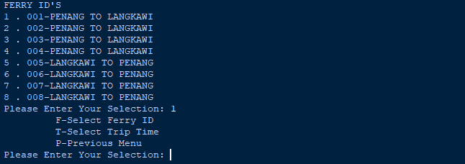

## LIST OF TRIPTIMES AVAILABLE

A close up of a logo

Description generated with very high confidence

## THE PREVIOUS MENU

A close up of a sign

Description generated with very high confidence

## BOOKING OF BUISNESS/ECONOMY CLASS

A screenshot of a cell phone

Description generated with very high confidence

* VIEWING SEATING ARRANGEMENT MENU

A screenshot of a cell phone

Description generated with very high confidence

* VIEWING SEATING ARRANGEMENT

A picture containing electronics

Description generated with high confidence

## READING FILE MODULE

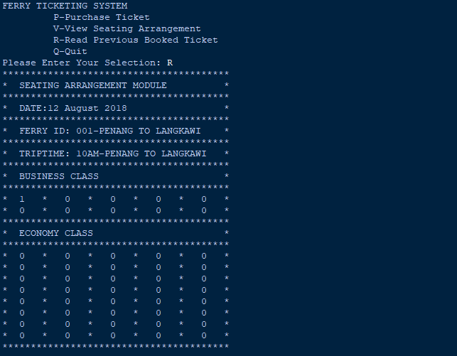

# MODULE COMPONENTS

## PROGRAM START

The program starts with initializing the global variables customer ferry id and customer trip time to. Defining the lists of business class, economy class, and eight lists for the total ferries. Trip Times and Ferry ids that are available are stored in the lists. After initializing the MAINMODULE function is called with the parameters given by the user that includes customer ferry id and customer trip time.

## MAINMODULE

The Main Module of the programs gives user the choice to select between purchasing a ticket, viewing seating arrangement, viewing the previously booked ticket or quitting the program. This is incorporated within a while true that works until the user presses the Q to exit.

## INFOMODULE

The info module gives the user a choice to select a ferry id and trip time after displaying a list of ferries and list of trip times available. The user selects the trip time and ferry id and these values gets assigned to the global variables customer ferry id and customer trip time.

## PURCHASING TICKET MODULE

The Purchasing ticket module gives the user a choice to select between business class and economy class of the selected ferry. Using users input it then assigns a seat to the user in the selected class after checking if the seat is empty or not. If the seat is empty it turns the initial value of the seat from 0 to 1. It keeps track of the seats if all of them are booked, it then it displays a message to the user to select the other class to proceed.

## VIEWING SEATING ARRANGEMENT

The viewing seating arrangement module displays the boarding pass to the user on the compiler. It firsts matches the selected ferry id from the list of ferry ids available. The matched ferry id’s is printed consisting of both the business class and the economy class of that ferry. This module also writes to the file FERRYTICKETINGDATA.txt the complete boarding pass. It reads the current date from the system and shows it on the boarding pass.

## READING MODULE

The reading module provides the user to read data from the file FERRYTICKETINGDATA.txt and shows it on the compiler screen. It is the boarding pass of the last user. It shows the booked tickets and the complete ferry details.

# ADDITIONAL FEATURES

## COMPLETE CONTROL

This program has complete control over the users input. It is incorporated within a while loop that displays invalid input when wrong key is pressed. The program never breaks or shows error through the whole process. The program starts with calling a function that sends the values of the global variables throughout the program. It gives the user a choice to move in between different modules of the program, helping the user to switch menus and return to any menu he desires to. (David L. Poole, 2017)

## TRACKING SEATS BOOKED

This program incorporates a module where tickets are booked by the user. The user is given an option to select between business class and economy class of the ferry by using the global variables. The global variables are used to keep track of the user’s selected ferry. This value is used to check whether the specified ferry’s seats are empty or not. This is done by checking if the seat of the class has a value ZERO or not. If the value is ZERO, it then changes it to ONE. It keeps track of bookings by using a flag. The flag is true when the seat is not empty and is false when the seat is empty. It then checks the value of the flag and if it’s ONE, it asks the user to select the other class to proceed. (Herman, 2013)

## VIEWING SEATING

This program gives the user to view seating of the selected ferry. This module reads the current date from the system and displays user a boarding ticket with the details including customer ferry id, trip-time, date and the business class and economy class of the ferry selected by the user through the global variable customer ferry id. (Miles, 2018)

## FILE INPUT & OUTPUT

This program also includes the FILE I/O. After the user has booked a ticket and selects the viewing arrangement module it writes the whole boarding pass to the file named as FERRYTICKETINGDATA.txt. This information includes the date, ferry id, trip-time, and the business and economy classes of the ferry. This complete boarding pass is written to a file. This program also includes with an option to view the last booked seat by reading the file. It displays the last boarding pass booked by the user on the compiler screen. (Zelle, 2004)

## PROPER COMMENTED

This program is well commented providing the user details about the modules made and how the control of the program works. Every modules start is commented how the module works. (Ashok Namdev Kamthane, 2018)

# ASSUMPTIONS

In this program it has been assumed that the user will book one ticket from the complete module and then go back to the main menu to book more tickets. The file contains the last booked tickets in the ferry. When the next user starts the program, he has the option to view the last booked tickets that has been saved in the file. The user can book more than two tickets but the latest one will be shown by the view seating arrangement module. The file has all the previous booked seats in the ferries. (Bradley N. Miller, 2010)

# REFRENCES

Ashok Namdev Kamthane, A. A. K., 2018. *Programming and Problem Solving with Python.* 1st ed. Delhi: McGraw-Hill Education .

Bradley N. Miller, D. L. R., 2010. *Python Programming in Context.* 1st ed. Ontario: Jones & Bartlett Publishers.

David L. Poole, A. K. M., 2017. *Artificial Intelligence.* 2nd ed. Cambridge: Cambridge University Press.

Herman, T., 2013. *A Functional Start to Computing with Python.* 1st ed. London: CRC Press.

Miles, R., 2018. *Begin to Code with Python.* 1st ed. New York: Pearson Education.

Zelle, J. M., 2004. *Python Programming: An Introduction to Computer Science.* 1st ed. Oregon: Franklin, Beedle & Associates.